**Exercise 4: Functions**

**Scenario 1:** Calculate the age of customers for eligibility checks.

**Script Output:**

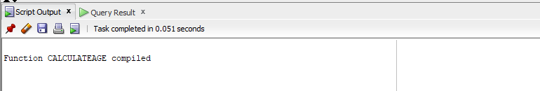

**Table Output:**

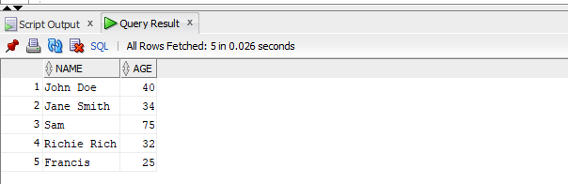

**Scenario 2:** The bank needs to compute the monthly installment for a loan.

**Table Output:**

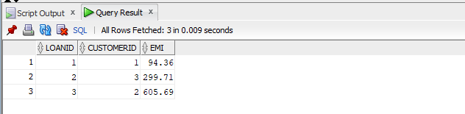

**Scenario 3:** Check if a customer has sufficient balance before making a transaction.

**Script Output:**

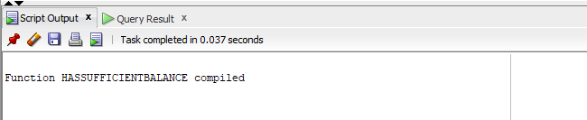

**Table Output:**

